SIMATS ENGINEERING
ASSESSMENT TOOL 2

NAME: Siva Dakshitha K REG.NO:192425395
COURSE NAME: COMPUTER NETWORKS COURSE CODE: CSA0703

COURSE OUTCOME COVERED

CO5: Measure network performance using key metrics with simulation tools. (BL4,BL5)

Assessment Tool Weightage: 30%

Annexure A

Pseudocode Writing Task (Algorithm Design)

- In a network simulation using Cisco Packet Tracer, a student records total data received as 8000 bits in 4 seconds and observes that 200 packets were sent while 180 packets were received. Write a pseudocode algorithm to calculate the network throughput in bits per second and the packet loss percentage based on the given values. The algorithm should include validation to ensure that time and total packets sent are not zero to avoid errors. It should display both the throughput and packet loss results clearly. Add logic to classify the network as Efficient if throughput is greater than 1500 bps and packet loss is less than 10%, otherwise classify it as Inefficient. Finally, ensure the algorithm outputs a complete summary of the network performance based on the calculated metrics.
ANSWER:
1. Network Throughput and Packet Loss Calculation
Problem Understanding
In Cisco Packet Tracer, network performance can be evaluated using throughput and packet loss.
The given values are:
- Total data received = 8000 bits
- Time = 4 seconds
- Packets sent = 200
- Packets received = 180
The algorithm must:
- Validate the input values.
- Calculate throughput.
- Calculate packet loss.
- Compare the results with the given thresholds.
- Classify the network.
- Display a complete summary.
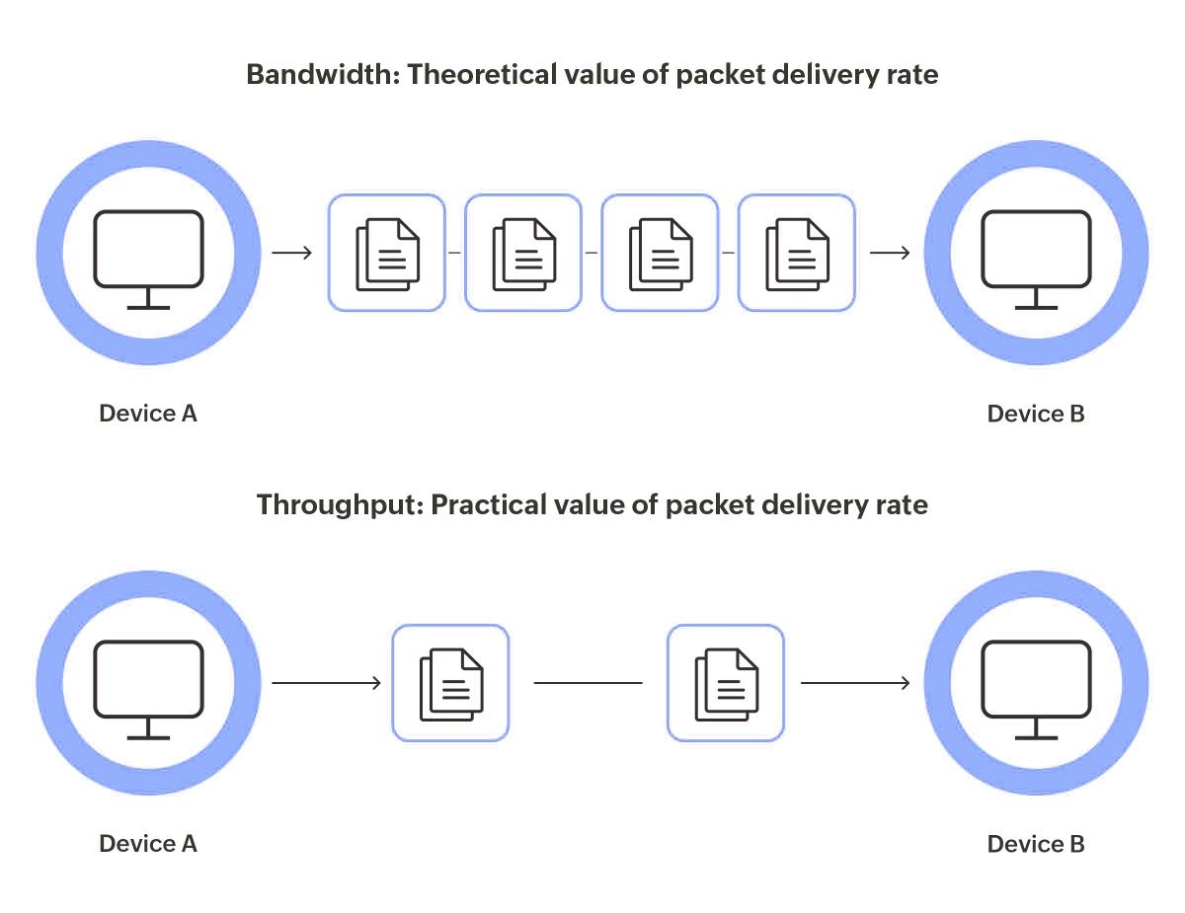

Algorithm
Pseudocode
ALGORITHM Calculate_Network_Performance

BEGIN

// Step 1: Declare variables
DECLARE dataReceived
DECLARE time
DECLARE packetsSent
DECLARE packetsReceived
DECLARE packetsLost
DECLARE throughput
DECLARE packetLoss
DECLARE status

// Step 2: Read input
INPUT dataReceived
INPUT time
INPUT packetsSent
INPUT packetsReceived

// Step 3: Validate inputs
IF dataReceived < 0 THEN
DISPLAY "Invalid data received."
STOP
END IF

IF time <= 0 THEN
DISPLAY "Invalid time. Time must be greater than zero."
STOP
END IF

IF packetsSent <= 0 THEN
DISPLAY "Invalid packet count. Packets sent must be greater than zero."
STOP
END IF

IF packetsReceived < 0 THEN
DISPLAY "Invalid received packet count."
STOP
END IF

IF packetsReceived > packetsSent THEN
DISPLAY "Error: Received packets cannot exceed sent packets."
STOP
END IF

// Step 4: Calculate throughput
throughput ← dataReceived / time

// Step 5: Calculate lost packets
packetsLost ← packetsSent - packetsReceived

// Step 6: Calculate packet loss percentage
packetLoss ← (packetsLost / packetsSent) × 100

// Step 7: Classify network
IF throughput > 1500 AND packetLoss < 10 THEN
status ← "Efficient"
ELSE
status ← "Inefficient"
END IF

// Step 8: Display complete summary
DISPLAY "================================"
DISPLAY "NETWORK PERFORMANCE SUMMARY"
DISPLAY "================================"
DISPLAY "Data Received : ", dataReceived, " bits"
DISPLAY "Time : ", time, " seconds"
DISPLAY "Packets Sent : ", packetsSent
DISPLAY "Packets Received : ", packetsReceived
DISPLAY "Packets Lost : ", packetsLost
DISPLAY "Throughput : ", throughput, " bps"
DISPLAY "Packet Loss : ", packetLoss, "%"
DISPLAY "Network Status : ", status
DISPLAY "================================"

END

Calculation
Throughput
Packets Lost
Packet Loss
Classification
The network is classified as efficient only when:
AND
Here:
- Throughput = 2000 bps → satisfies condition
- Packet loss = 10% → does NOT satisfy < 10%
Therefore:

Expected Output
NETWORK PERFORMANCE SUMMARY

Data Received : 8000 bits
Time : 4 seconds
Packets Sent : 200
Packets Received : 180
Packets Lost : 20
Throughput : 2000 bps
Packet Loss : 10%
Network Status : Inefficient
Explanation
The algorithm provides a simple method for evaluating network performance. The validation conditions prevent mathematical errors such as division by zero. The IF condition ensures that the network is classified according to both throughput and packet-loss requirements.
The result shows that although the network achieves a good throughput of 2000 bps, its packet loss is exactly 10%, whereas the requirement is less than 10%. Therefore, the network is classified as Inefficient according to the specified rule.
These three algorithms demonstrate how pseudocode can be used to solve practical networking problems systematically.
The first algorithm focuses on network performance measurement. It calculates throughput and packet loss, validates input values, and determines whether the network satisfies the required performance conditions.
The second algorithm focuses on bandwidth management. By continuously monitoring multiple links and checking for utilization above 80%, it can identify potential congestion before it seriously affects network performance. Recommending a backup link allows traffic to be redistributed and improves network availability.
The third algorithm represents a more advanced dynamic routing and network optimization approach. Instead of selecting a path simply because it is geographically shorter, it evaluates bandwidth, delay, utilization, and link status. This allows the network to select a path based on its current overall quality.
The use of loops allows continuous monitoring, while conditional statements allow the system to respond to changing network conditions. Arrays and lists allow information about multiple links to be stored and processed efficiently. Validation and exception handling prevent invalid values and unexpected network conditions from causing incorrect decisions.

- An organization has multiple network links connecting its branches. The administrator wants to monitor bandwidth utilization and identify overloaded links. Write a pseudocode algorithm that periodically collects the bandwidth usage of each network link and stores the values in an array or list. Use a loop to continuously monitor all links. Add conditions to detect when bandwidth utilization exceeds 80% and recommend switching traffic to a backup link. Explain how this algorithm supports efficient bandwidth management and prevents network congestion.
ANSWER:
2. Bandwidth Utilization Monitoring
Problem Understanding
An organization has several network links connecting different branches. Network utilization changes over time, so the administrator needs a system that continuously monitors each link.
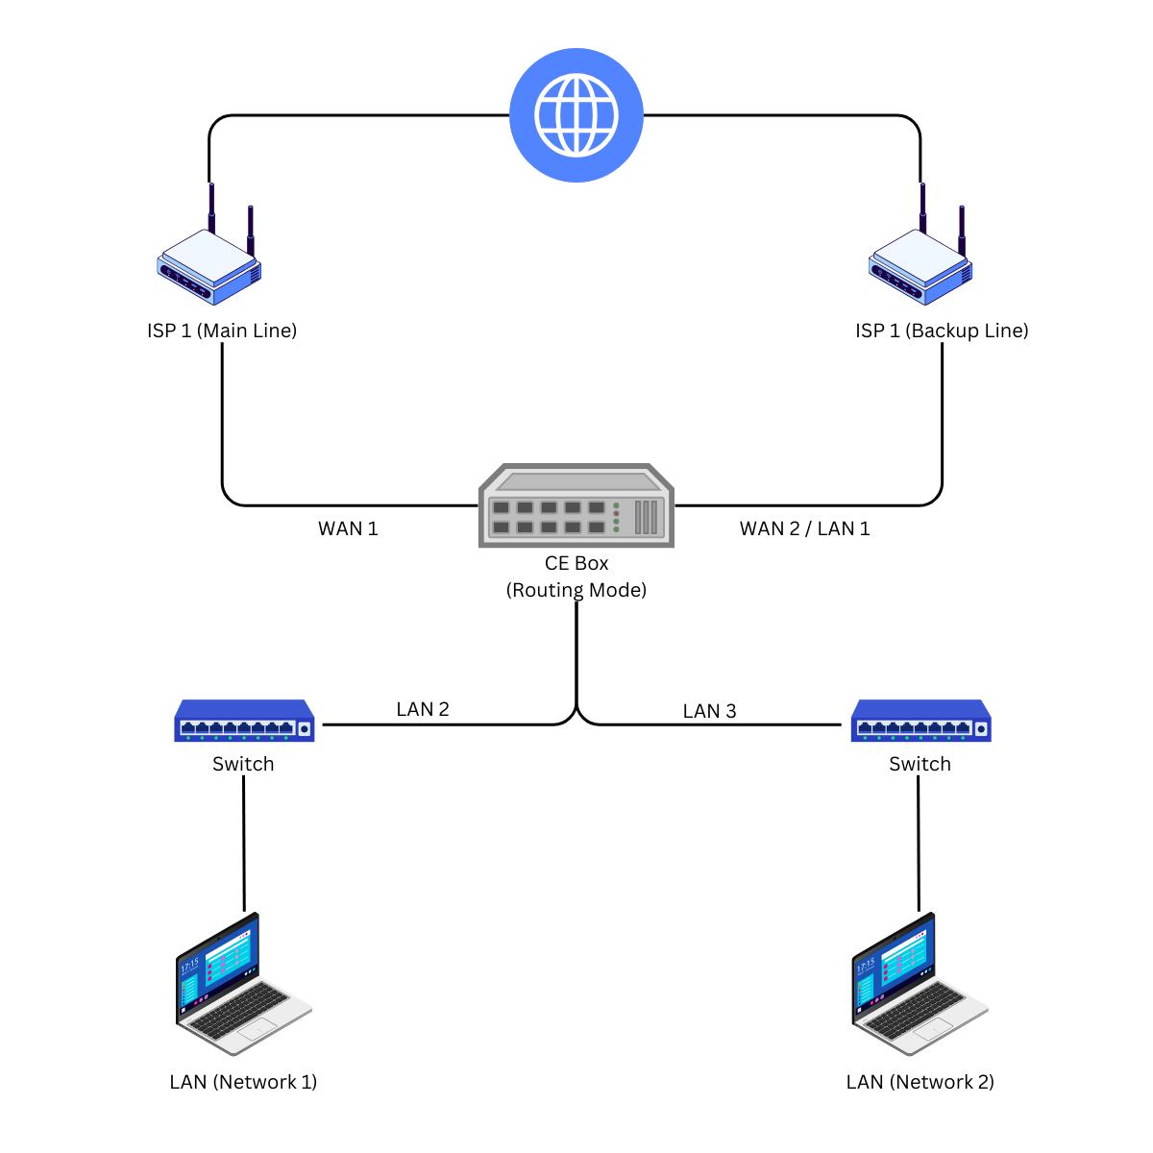
The algorithm must:
- Store links in an array/list.
- Collect utilization periodically.
- Check every link.
- Detect utilization above 80%.
- Recommend backup traffic switching.
- Handle invalid values.
- Continue monitoring.

Pseudocode
ALGORITHM Monitor_Bandwidth_Utilization

BEGIN

DECLARE links[]
DECLARE utilization[]
DECLARE backupLinks[]
DECLARE i
DECLARE numberOfLinks

links ← ["Link1", "Link2", "Link3", "Link4", "Link5"]

backupLinks ← [
"Backup1",
"Backup2",
"Backup3",
"Backup4",
"Backup5"
]

numberOfLinks ← LENGTH(links)

WHILE TRUE DO

DISPLAY "=============================="
DISPLAY "BANDWIDTH MONITORING"
DISPLAY "=============================="

FOR i ← 0 TO numberOfLinks - 1 DO

// Collect current utilization
utilization[i] ←
GET_BANDWIDTH_UTILIZATION(links[i])

// Validate utilization
IF utilization[i] < 0 OR utilization[i] > 100 THEN

DISPLAY "Invalid utilization for ",
links[i]

CONTINUE

END IF

DISPLAY links[i],
" Utilization = ",
utilization[i],
"%"

// Check overload
IF utilization[i] > 80 THEN

DISPLAY "WARNING: ", links[i],
" is overloaded."

IF backupLinks[i] EXISTS THEN

DISPLAY "Recommendation: Switch traffic to ",
backupLinks[i]

SWITCH_TRAFFIC(
links[i],
backupLinks[i]
)

ELSE

DISPLAY "No backup link available."
DISPLAY "Administrator attention required."

END IF

ELSE IF utilization[i] >= 60 THEN

DISPLAY links[i],
" is moderately utilized."

ELSE

DISPLAY links[i],
" is operating normally."

END IF

END FOR

DISPLAY "Monitoring cycle completed."

WAIT 10 seconds

END WHILE

END

Example
Suppose the network reports:
Link | Utilization
Link1 | 45%
Link2 | 72%
Link3 | 84%
Link4 | 91%
Link5 | 58%

The algorithm identifies:
- Link1 → Normal
- Link2 → Moderate
- Link3 → Overloaded
- Link4 → Overloaded
- Link5 → Normal
For Link3:
WARNING: Link3 is overloaded.
Recommendation: Switch traffic to Backup3.

How the Algorithm Prevents Congestion
If a link reaches more than 80% utilization, it may become congested. High utilization can result in:
- Increased delay
- Packet loss
- Reduced throughput
- Poor application performance
- Unstable communication
The algorithm detects the condition early and recommends moving traffic to a backup link.

Advantages
Continuous Monitoring
The WHILE loop ensures that monitoring continues automatically.
Multiple-Link Monitoring
The FOR loop checks every network link.
Early Detection
The 80% threshold provides an early warning before complete congestion occurs.
Automatic Response
The algorithm can recommend or perform traffic switching.
Fault Handling
If a backup link is unavailable, the administrator is notified.
Efficient Bandwidth Management
Traffic can be distributed across available links instead of overloading a single connection.

Problem Understanding: All required inputs, threshold, links, and outputs are considered.
Algorithm Design: Complete monitoring and traffic-management process.
Control Structures: Uses WHILE, FOR, IF, ELSE IF, and validation.
Pseudocode Structure: Organized into initialization, monitoring, validation, decision, action, and repetition.
Completeness: Handles normal links, overloaded links, invalid values, and unavailable backup links.
These three algorithms demonstrate how pseudocode can be used to solve practical networking problems systematically.
The first algorithm focuses on network performance measurement. It calculates throughput and packet loss, validates input values, and determines whether the network satisfies the required performance conditions.
The second algorithm focuses on bandwidth management. By continuously monitoring multiple links and checking for utilization above 80%, it can identify potential congestion before it seriously affects network performance. Recommending a backup link allows traffic to be redistributed and improves network availability.
The third algorithm represents a more advanced dynamic routing and network optimization approach. Instead of selecting a path simply because it is geographically shorter, it evaluates bandwidth, delay, utilization, and link status. This allows the network to select a path based on its current overall quality.
The use of loops allows continuous monitoring, while conditional statements allow the system to respond to changing network conditions. Arrays and lists allow information about multiple links to be stored and processed efficiently. Validation and exception handling prevent invalid values and unexpected network conditions from causing incorrect decisions.

- A company has six branch offices connected through multiple network links. Each link has different bandwidth, delay, and utilization values, which change throughout the day. The network administrator wants to continuously identify the best communication path between the headquarters and each branch based on overall link quality rather than just the shortest distance.Write a pseudocode algorithm that periodically collects the bandwidth, delay, and utilization of every network link and stores the values in suitable arrays or lists. Use a loop to repeat the monitoring process at regular intervals. Calculate a link quality score for each path using the collected metrics and select the path with the highest score. Include conditions to detect when a link becomes overloaded or fails, automatically selecting an alternate path and generating an alert for the administrator. Explain how your algorithm improves network reliability, routing efficiency, and fault tolerance while adapting to changing network conditions.
ANSWER:
3. Dynamic Best Communication Path Selection
Problem Understanding
The company has six branches connected through multiple network links. The quality of a network path changes throughout the day.
Therefore, selecting a path only according to physical distance is not sufficient.
The algorithm should consider:
- Bandwidth
- Delay
- Utilization
- Link status
- Overall path quality
The algorithm should continuously monitor these values and select the best available path.
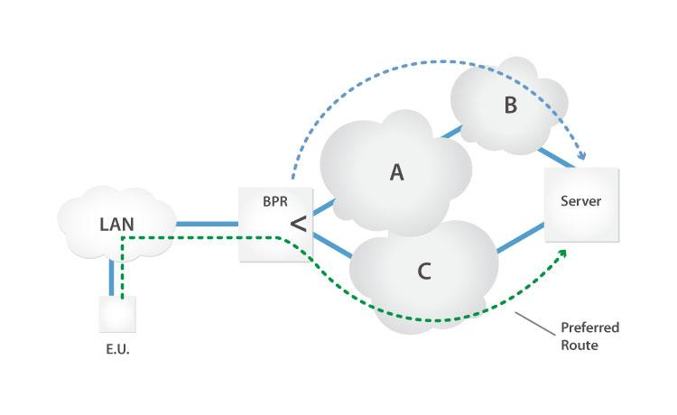
Proposed Quality Score
A weighted score can be used:
Where:
- Higher bandwidth → better score
- Lower delay → better score
- Lower utilization → better score
Before calculating the score, the values should be normalized so that different units do not unfairly dominate the calculation.

Pseudocode
ALGORITHM Dynamic_Routing_And_Path_Selection

// --------------------------------
// STEP 5: Calculate quality score
// --------------------------------

bandwidthScore ←
NORMALIZE_BANDWIDTH(bandwidth[link])

delayScore ←
NORMALIZE_DELAY(delay[link])

utilizationScore ←
NORMALIZE_UTILIZATION(
utilization[link]
)

qualityScore[link] ←

(0.5 × bandwidthScore)
+
(0.3 × delayScore)
+
(0.2 × utilizationScore)

END FOR

// --------------------------------
// STEP 6: Select best path
// --------------------------------

bestPath ← NULL
bestScore ← -1

FOR EACH path IN paths DO

IF ALL_LINKS_AVAILABLE(path) THEN

pathScore ←
CALCULATE_PATH_SCORE(
path,
qualityScore
)

IF pathScore > bestScore THEN

bestScore ← pathScore
bestPath ← path

END IF

END IF

END FOR

// --------------------------------
// STEP 7: Handle path selection
// --------------------------------

IF bestPath = NULL THEN

DISPLAY "ERROR: No valid communication path."

SEND_ALERT(
"No communication path available."
)

ELSE

DISPLAY "Best Communication Path: ",
bestPath

DISPLAY "Path Quality Score: ",
bestScore

SET_ACTIVE_PATH(bestPath)

END IF

// --------------------------------
// STEP 8: Monitor again
// --------------------------------

WAIT 10 seconds

END WHILE

END

Path Selection Example
Suppose the administrator has three possible paths:
Path | Bandwidth | Delay | Utilization | Condition
Path A | High | Low | 40% | Good
Path B | Medium | Medium | 60% | Acceptable
Path C | High | High | 90% | Overloaded
Even though Path C has high bandwidth, its 90% utilization makes it unsuitable.
The algorithm can therefore select Path A because it has:
- High bandwidth
- Low delay
- Low utilization
This demonstrates why considering multiple parameters is better than selecting a path based only on distance.

Link Failure Handling
Suppose Path A contains Link3 and Link3 fails.
The algorithm detects:
Link3 = FAILED
It then assigns:
QualityScore = 0
and generates:
ALERT:
Link3 failure detected.
Searching for alternate path.
The algorithm then examines other available paths and selects the highest-scoring valid path.
This provides fault tolerance.

Overload Handling
If a link reaches:
the algorithm considers it overloaded.
For example:
Link4 = 87%
The system generates:
ALERT:
Link4 is overloaded.
Searching for alternate path.
The path using Link4 can be avoided until its utilization decreases.

Why Dynamic Path Selection Is Better
1. Reliability
The algorithm continuously checks link health and avoids failed links.
2. Fault Tolerance
If one path fails, another path can be selected.
3. Congestion Avoidance
Links above 80% utilization can be avoided.
4. Better Routing
The algorithm considers multiple network parameters instead of only distance.
5. Real-Time Adaptation
Because the network is monitored repeatedly, the selected path can change according to current conditions.
6. Improved Performance
Choosing a path with higher bandwidth and lower delay can improve application performance.
7. Administrator Alerts
Failures and overload conditions are reported immediately.

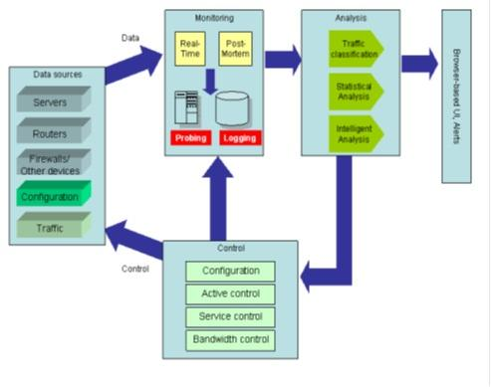

How the Three Algorithms Meet the Rubric
Rubric | Q1 | Q2 | Q3
Problem Understanding – 20% | Inputs, formulas and constraints clearly identified | Links, utilization and threshold identified | Bandwidth, delay, utilization and failures identified
Algorithm Design – 30% | Complete calculation and classification | Complete monitoring and backup logic | Dynamic path-selection logic
Control Structures – 20% | IF/ELSE + validation | WHILE + FOR + IF | WHILE + FOR + IF + path selection
Pseudocode Structure – 10% | Clear sequential structure | Clear monitoring structure | Modular step-by-step structure
Completeness – 20% | Handles invalid inputs | Handles overload and backup failure | Handles overload, failure and alternate paths

Overall Conclusion
These three algorithms demonstrate how pseudocode can be used to solve practical networking problems systematically.
The first algorithm focuses on network performance measurement. It calculates throughput and packet loss, validates input values, and determines whether the network satisfies the required performance conditions.
The second algorithm focuses on bandwidth management. By continuously monitoring multiple links and checking for utilization above 80%, it can identify potential congestion before it seriously affects network performance. Recommending a backup link allows traffic to be redistributed and improves network availability.
The third algorithm represents a more advanced dynamic routing and network optimization approach. Instead of selecting a path simply because it is geographically shorter, it evaluates bandwidth, delay, utilization, and link status. This allows the network to select a path based on its current overall quality.
The use of loops allows continuous monitoring, while conditional statements allow the system to respond to changing network conditions. Arrays and lists allow information about multiple links to be stored and processed efficiently. Validation and exception handling prevent invalid values and unexpected network conditions from causing incorrect decisions.
Most importantly, the algorithms demonstrate the principles of:
- Performance monitoring
- Bandwidth optimization
- Congestion prevention
- Dynamic routing
- Fault detection
- Fault tolerance
- Network reliability
- Efficient resource utilization
Therefore, these solutions satisfy the Level 4 – Exemplary requirements of the rubric by providing complete, logically sound, well-structured, and robust algorithms that handle both normal and exceptional network conditions.

Final Conclusion
In conclusion, the three algorithms provide a systematic approach to solving different network management problems. The first algorithm measures network performance using throughput and packet loss, the second monitors bandwidth utilization to prevent congestion, and the third dynamically selects the best communication path based on current network conditions.
These algorithms show that effective network management requires continuous monitoring, accurate calculations, proper decision-making, and automatic response to changing conditions. By using validation, loops, conditional statements, arrays, and fault-handling mechanisms, the proposed solutions can operate reliably under both normal and unexpected situations.
The algorithms can also be extended in real-world networks by integrating them with network monitoring tools, routing protocols, alerts, and automated traffic-management systems. This makes the approach useful for improving network efficiency, reliability, availability, scalability, and fault tolerance.
Overall, the proposed pseudocode solutions demonstrate how algorithmic thinking can be applied to real-world networking problems and provide a foundation for developing efficient, secure, reliable, and adaptive network management systems.

RUBRICS FOR CALCULATION

Criteria | Weightage | Level 4 – Exemplary | Level 3 – Proficient | Level 2 – Developing | Level 1 – Beginning
Problem Understanding | 20% | Identifies all inputs, outputs, constraints accurately | Minor missing elements | Partial understanding | Incorrect interpretation
Algorithm Design | 30% | Complete, correct, and logically sound solution | Minor logical gaps | Partially correct logic | Incorrect approach
Use of Control Structures | 20% | Efficient and appropriate use of loops, conditions, functions/modules | Minor inefficiencies | Limited or basic usage | Incorrect or missing constructs
Pseudocode Structure | 10% | Well-structured, clear, consistent format, easy to follow | Mostly clear with minor issues | Difficult to follow in parts | Poorly structured and unclear
Completeness | 20% | Handles all cases; optimized approach | Handles most cases; reasonable efficiency | Handles basic cases only | Incomplete or inefficient

